Acacia Ridge Presbyterian Church

Process Documentation For:
Uploading Sermons to the ARPC Website

Version: 1.0
Author: Andrew Nielson

Document Version History
Version No | Issue Date | Nature of Amendment | Editor
1.0 | 20/01/2015 | Initial Draft | Andrew Nielson

Glossary
Term | Definition
Audacity | Audacity is a free Open-Source program for editing sound files. http://audacity.sourceforge.net/

Table of Contents:
1.0 Background: 2
2.0 Transferring the sermon recording 3
3.0 Editing the Sermon 3
4.0 Uploading the Sermon to the website 6
5.0 Add the link to the sermon mp3 file to the ARPC website 8

Background:
Every Sunday the sound engineer rostered on for each service should record the sermon using Audacity. Ideally this recording should also be exported as a .wav file which can then be transferred, edited, converted to MP3 and uploaded to the church website.

Transferring the sermon recording
Although you could edit and upload the sermon recording on the church PC that it is recorded on (in the main auditorium), it is probably easier to transfer it to USB drive and edit it in the comfort of your home and at a suitable time.

  - Insert your USB drive into the church auditorium PC (it should auto-detect it)
  - Find the latest sermon recording/s that you want to transfer.
This can be done by:
Opening Audacity and browsing recently opened files
(File -> Recent Files) and exporting the file as a .wav file to your USB drive (File -> Export Audio).
OR
Opening Windows Explorer and going to C:\Users\SoundDesk\My Documents\Service Recordings\[YEAR]
  - Verify that the file/s copied to your USB drive by opening windows explorer and browsing to your USB drive

Another possible method to transfer the sermon recording is to remotely connect to the church NAS (Weber Hsu or Martin Homann look after this device).

Editing the Sermon

The sermon will need to be editing

  - If you haven’t already downloaded and installed
Audacity (http://audacity.sourceforge.net/) and LAME encoder (http://audacity.sourceforge.net/help/faq_i18n?s=install&i=lame-mp3) then download and install them.
  - Open the sermon .wav file that you want to edit (File -> Open).
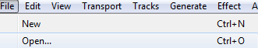
  - Listen to the beginning of the file. Would it make sense to a new listener? Are there noises, gaps or other announcements that need to be removed from the start of the sermon? If so, then select audio that needs to be removed and delete it (Edit -> Delete).
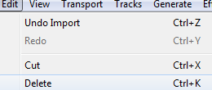
  - Listen to the end of the file. Again, are there any noises, gaps, other announcements, songs or question and answer times that need to be removed from the end of the sermon? If so, then again select audio that needs to be removed and delete it (Edit -> Delete).
  - Once the start and the end of the file has been edited and is all good you should normalize the audio so that it is boosted to it’s maximum possible volume. To do this, select all of the audio (Ctrl+a) and then select “Normalize” from the “Effect” menu.
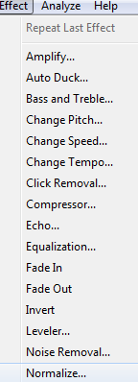
  - Accept the default limit of -1db and click the “OK” button.
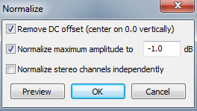
  - Once the file has been normalized play back a bit to confirm that it’s OK.
  - Export the file to an mp3 file by selecting “Export Audio” from the “File” menu.
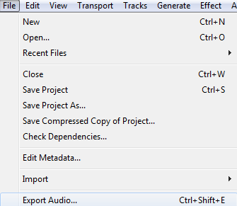
  - Click the “Options” button and ensure that “Constant” Bit Rate mode is selected, Quality is set to 128kbps, Channel mode is “Joint Stereo” and then click the OK button.
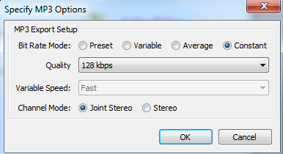
  - The filename should be in the format of yyyymmdd-Sermonname-Service (e.g 20150118-Psalm6-AM if you were saving more than one service recording for the same day). The reason for the format is to make files easy to find and they will sort in chronological order.
Verify that the title of the filename is correct and then click the “Save” button.
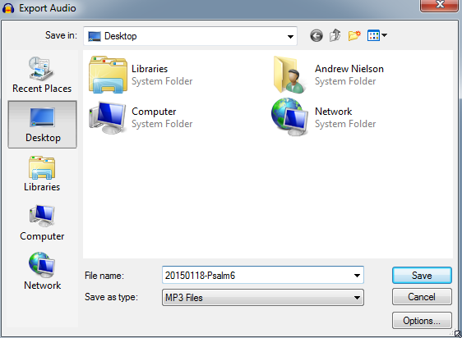

Uploading the Sermon to the website
  - Open a web-browser and browse to http://www.bluehost.com
  - Click the “login” button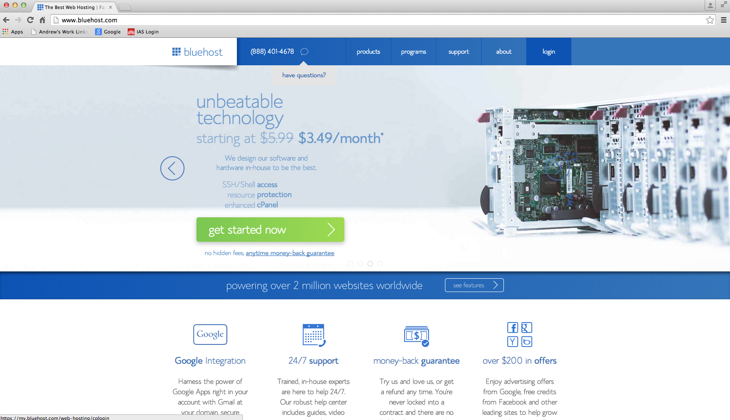
  - Enter the login credentials (username is arpcorga): 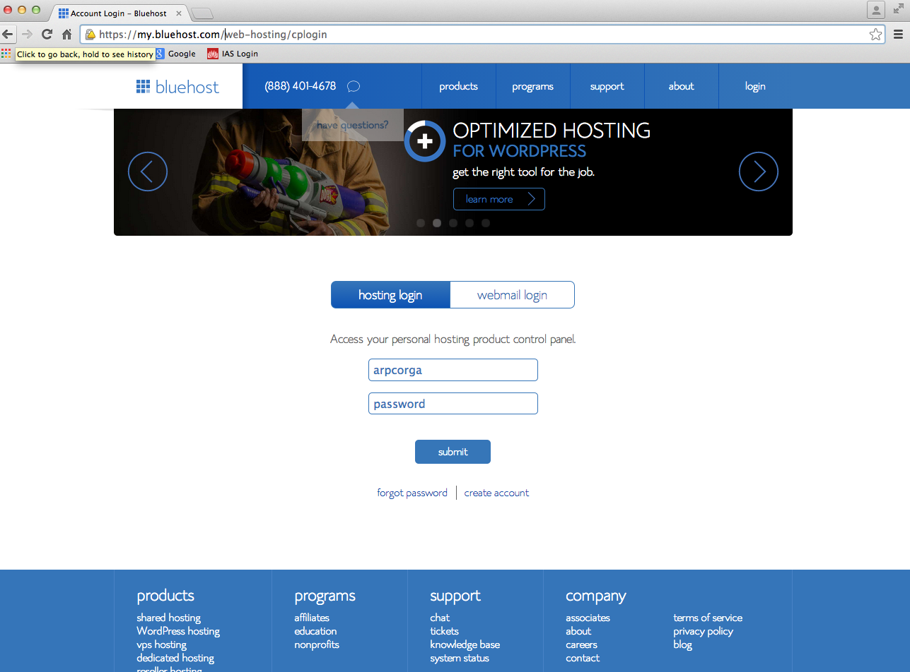
  - Click the “Hosting” button from the top menu:
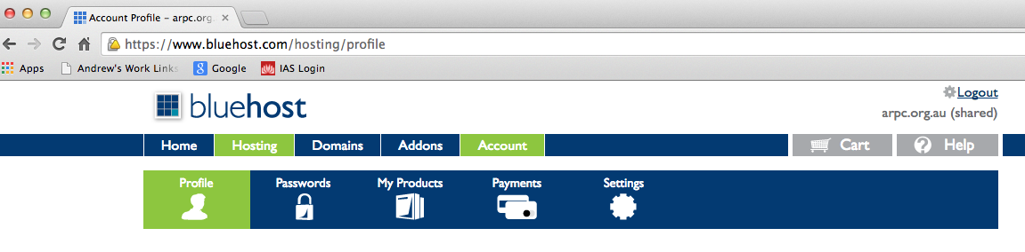
  - Click the “File Manager” icon
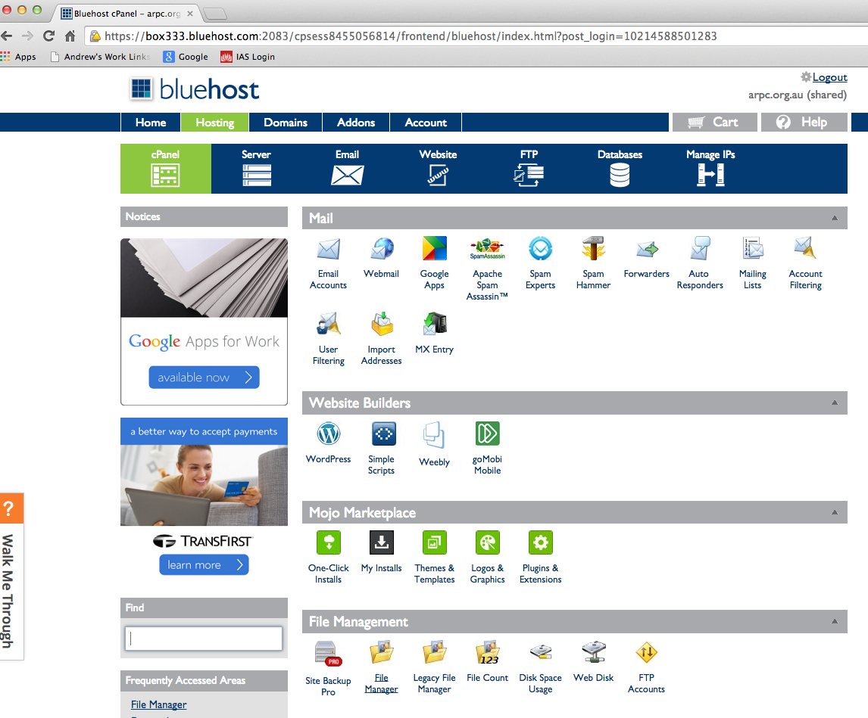
  - Ensure that “Web Root” is selected and click the “Go” button:
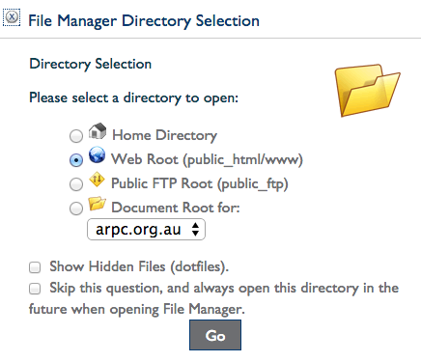
  - Navigate to the folder you want to upload the mp3 file to by double-clicking the Uploads folder, then double-click the Sermons folder, then double-click the folder of the current year (e.g 2015):
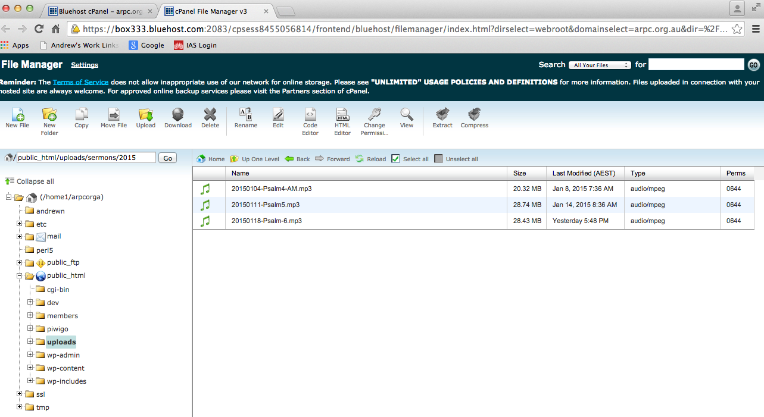
  - Click the “Upload” icon
  - Click the “Choose File” button:
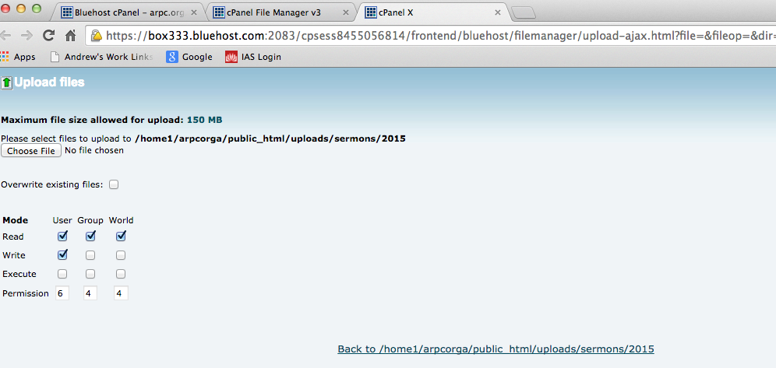
  - Navigate to the file you want to upload and then click “open”
  - Monitor your upload progress until it completes successfully.

Add the link to the sermon mp3 file to the ARPC website
The ARPC website is hosted by Bluehost but runs on a platform called Wordpress. There is a lot of documentation and information on Wordpress on the Wordpress website (https://wordpress.com/).

  - Open a web-browser and browse to http://www.arpc.org.au/wp-admin
  - Enter the username (admin) and password and click the “Log In” button:
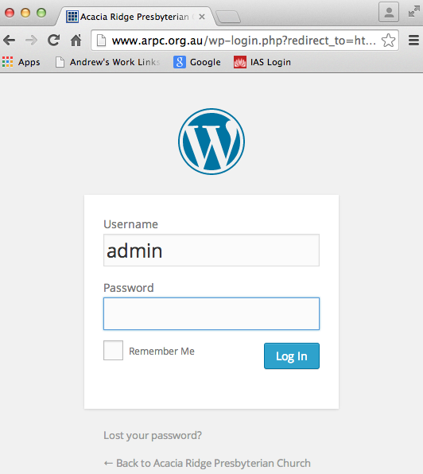
  - Navigate to the list of website pages by selecting Pages -> All Pages from the dashboard menu:
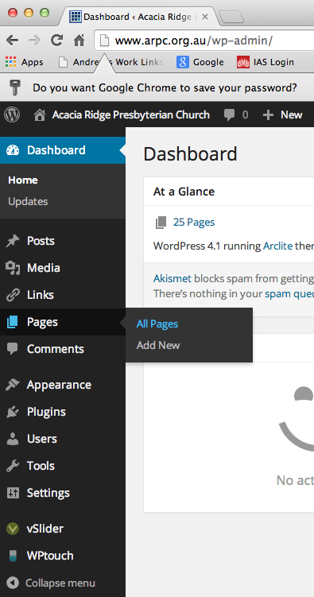

  - You will probably need to click the “>” next page button to get to the list of website pages that has the Sermons page:
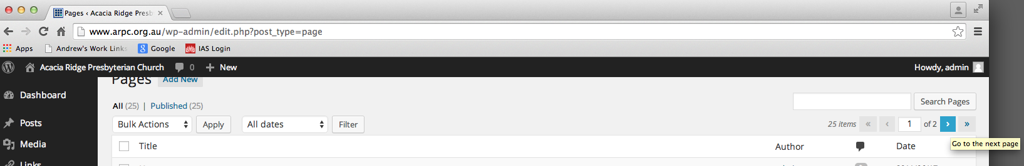
  - Edit the Sermons page by clicking the “Edit” link under the “Sermons” page:
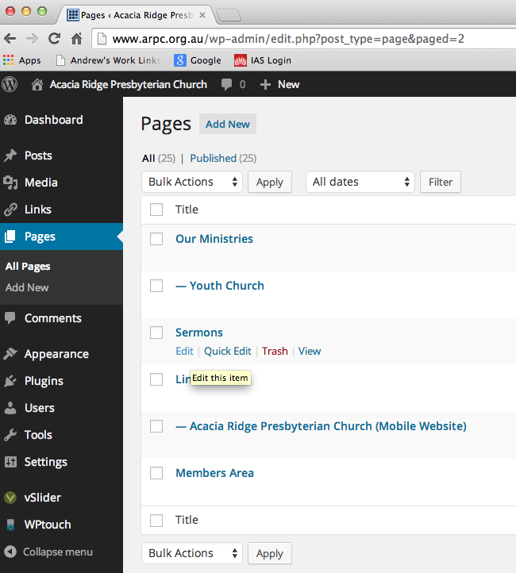

  - Click to select the Sermon Name cell for the top sermon (the “Psalm 6” in this example):
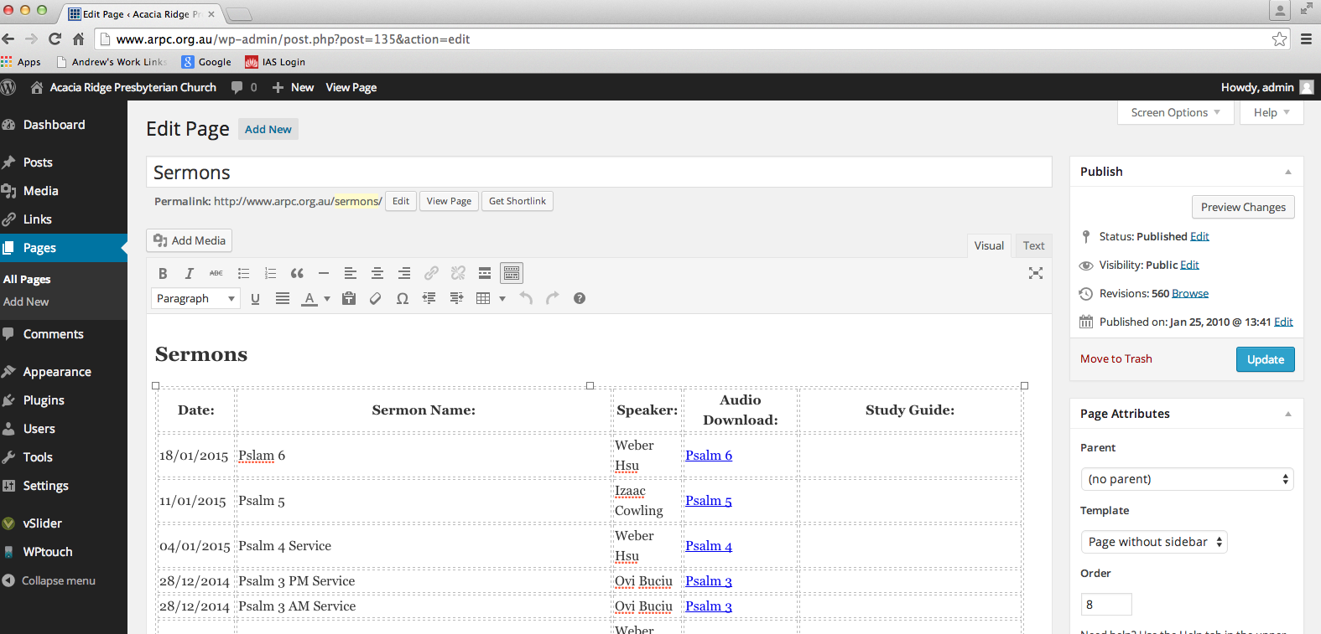
  - Click the Tables dropdown icon and then click “Row” and “Insert row before” to create a new row:
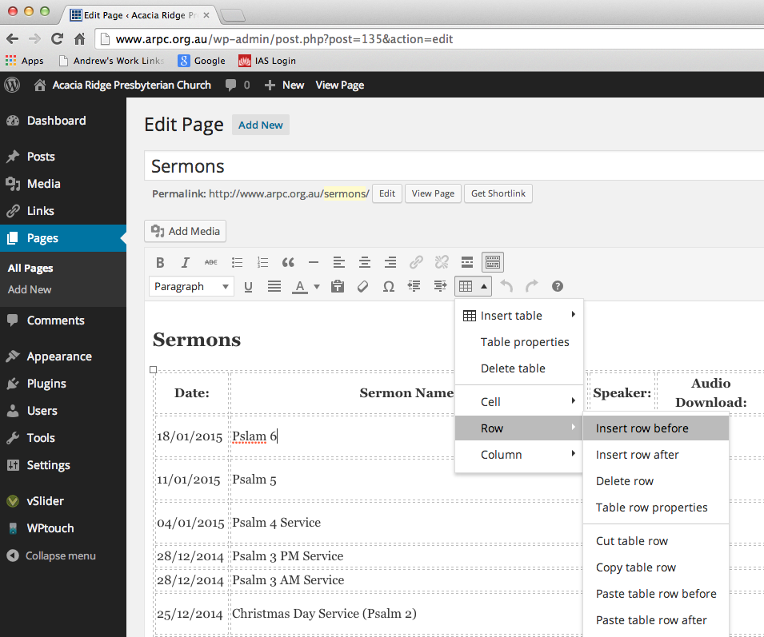
  - Enter the date, sermon name and speaker for the new sermon:
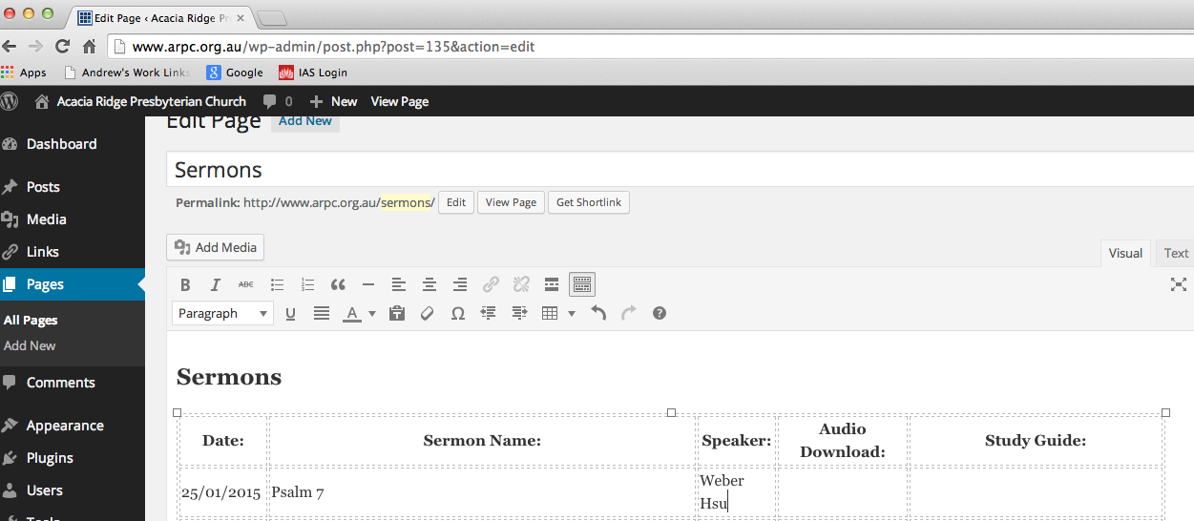

  - Copy and paste the download link for the last sermon:
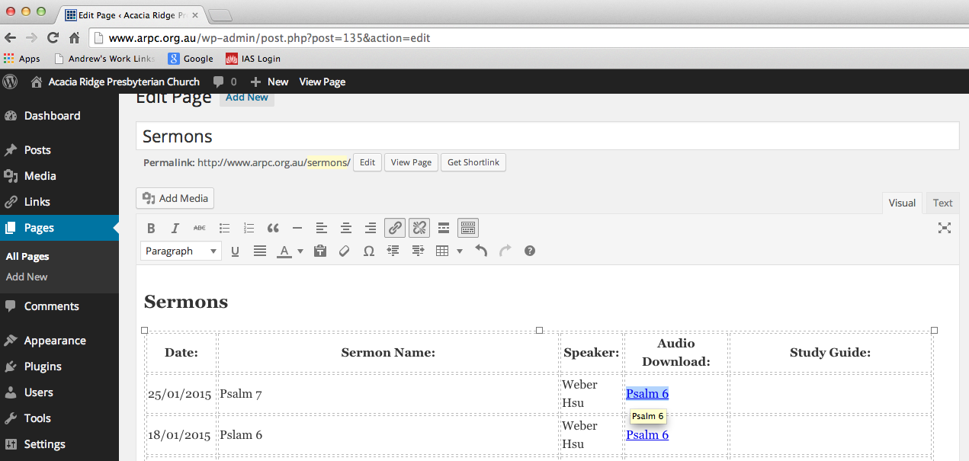

  - Change the name of the link to the correct name (note you may have to type in the middle of the text so that it continues to be a link):
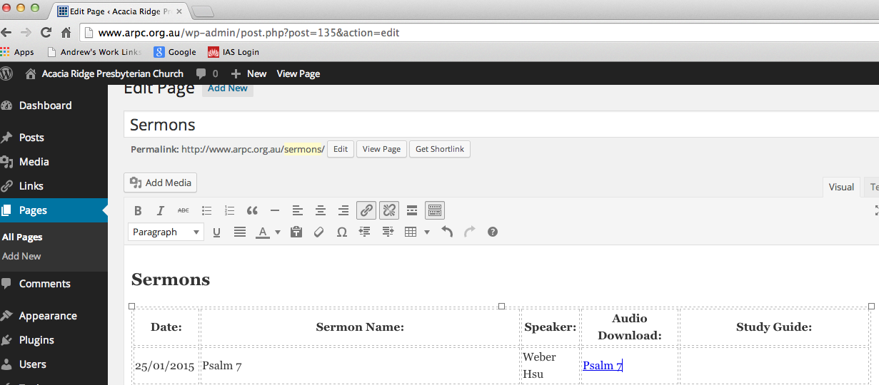

  - Change the new link to point to the new file by clicking to select the whole link and then clicking the “insert/edit link” button:
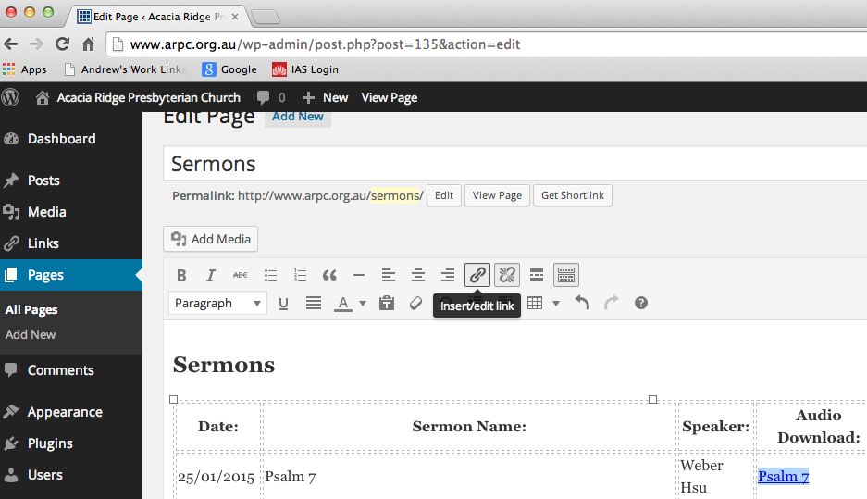

  - Update the link URL to point to the new mp3 file and have the correct title and click the Update button:
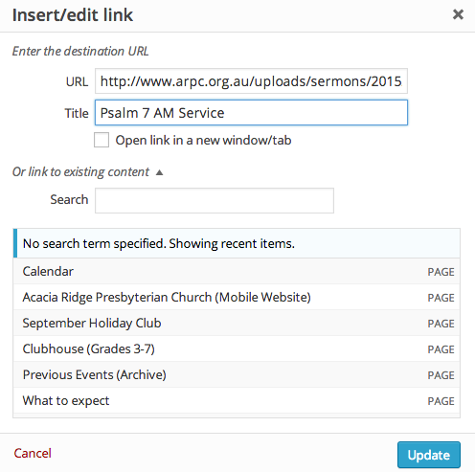

  - Save the webpage by clicking the “Update” button:
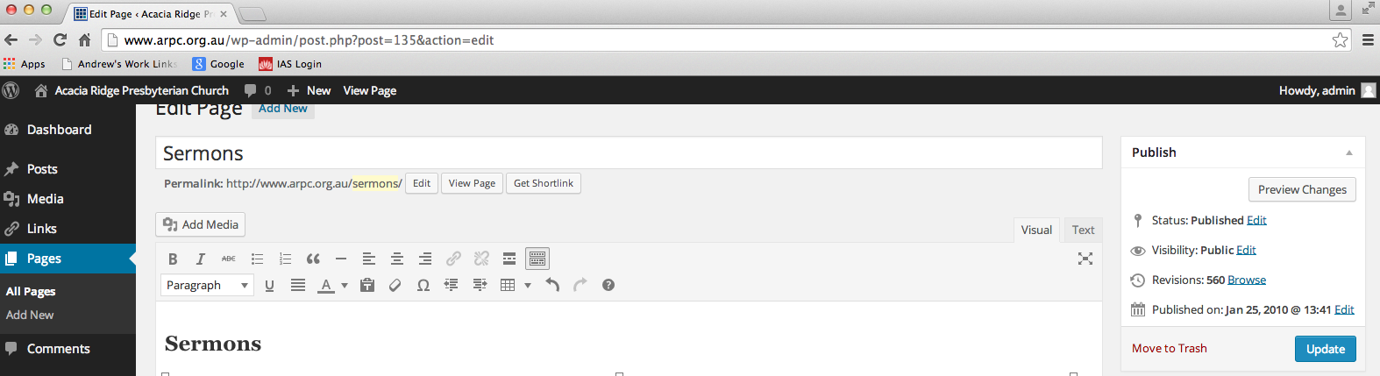

  - Check that the webpage is correct by opening a browser to http://www.arpc.org.au/sermons:
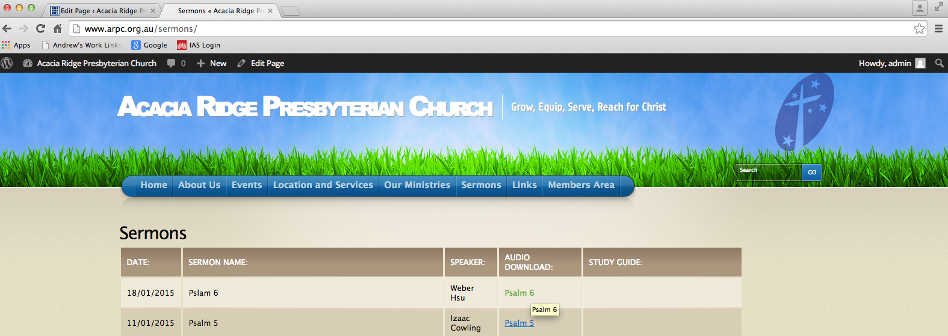

  - Click on the audio download link to confirm that it plays correctly:
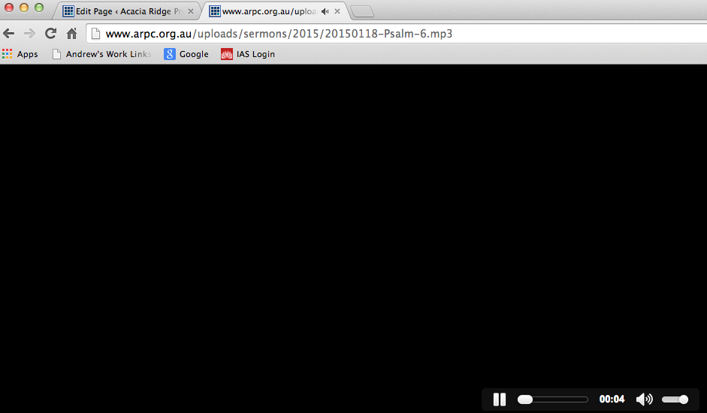

  - If it does then Logout of Wordpress by clicking “Howdy, admin” and then “Log Out”:
