**Term 3 Equip**

**The Gospel at Work**

**Studies in Acts chapters 8 – 15**

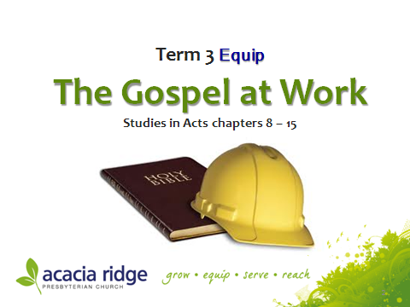

**The Setting of Acts c. a.d. 30–60**

The book of Acts records the spread of the gospel from Jerusalem to Rome, thus fulfilling the risen Christ’s words to his apostles in [Acts 1:8](http://www.esvbible.org/Acts%2B1.8).

In this series of studies we trace the movement of Christ’s Church as it shifts from Jewish origins through to being good news for people from every tribe and nation. Founded on the Apostles with Christ as the Cornerstone Christianity spreads our across the globe with remarkable speed and success even though constantly it is under attack and believers face intense persecution.

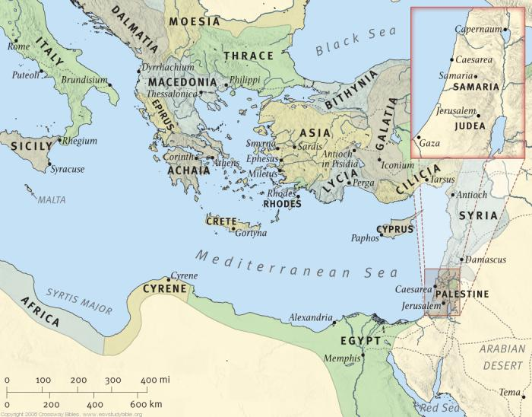

### Timeline for Acts

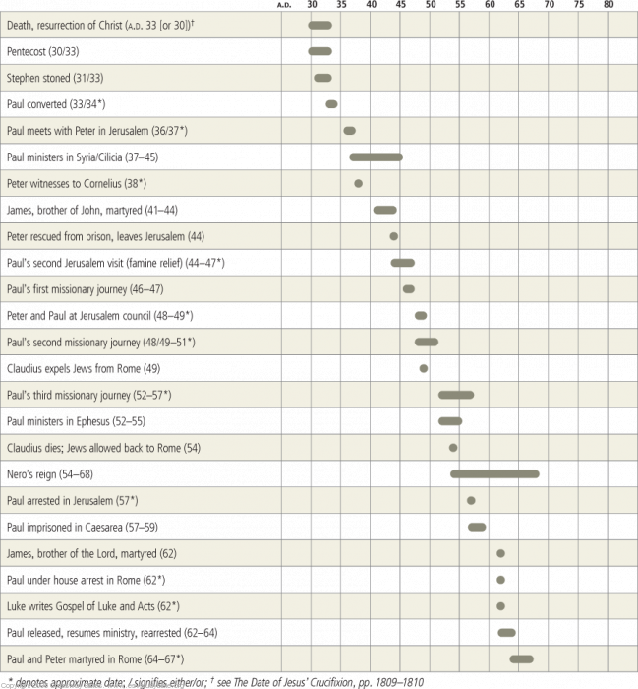

****Equipping in Acts STUDY ONE

**C:\Documents and Settings\Dan\Local Settings\Temporary Internet Files\Content.IE5\AS4WMIWL\MCj02925940000[1].wmfKey verse:** Acts 8:4.

Those who had been scattered preached the word wherever they went.**Big Idea:** Effective Christian living is built on the one true apostolic Christ.

Kick Off

Spot the fake in this puzzle.

Which one is the odd one out?

When it comes to spotting fake Jesus’, what criteria do you use?

**STUDY   
Read Acts 8:1-25.**

1. There are two types of scattering which use two different words in the Greek. One is scattered to be forever lost as the scattering of ashes on the ocean. The other is scattering as of seed for planting. Which scattering would fit the context of intense persecution the believers are facing? The scattering used here is the sowing kind. Why is this so?

2. v4 is a general statement of what was happening all over the place. v5 is a specific singular example of v4. Other specific examples are recorded in Acts 11:19.

What did Philip do and how do you think he would have gone about doing it?

What is really radical about Phillip’s actions? Cf. John 4:9 if you can’t guess.

What is the outcome in Samaria v8?

3. Contrast the similarities and the differences between Philip and Simon vv 9-13?

4. Why did God delay the Holy Spirit’s coming to the Samaritans until the Apostles arrived?

Consider Ephesians 2:20 and consider Jesus’ words to the twelve apostles in John 14:26 and 17:26. How important are the apostles in defining the authentic Jesus?

What important message are we to get from God in him connecting his blessing of the Holy Spirit with the presence of his Apostles?

5. How does Simon view the Holy Spirit?

6. What is the difference between a power and a person?

Since the Spirit is a person what does it mean for a person to be filled with the Spirit?

7. Is Simon’s request in v24 a pious plea or defiant disobedience?

THINK AND APPLY

There are many different “Christs” people promote. What true measuring stick are we to use today to assess the many different “Christs” on offer?

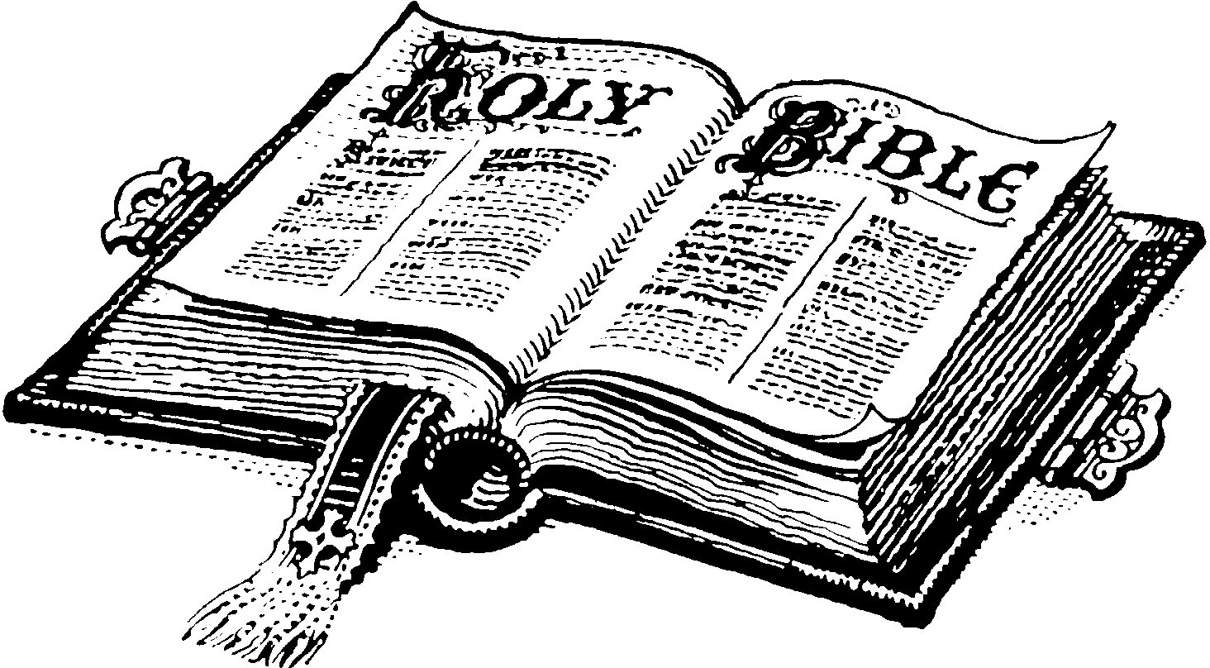PRAYER

**For next week**

**Read**

**Acts 8:26-40**

**What can you pray about arising from this study?**

****Equipping in Acts STUDY TWO

**C:\Documents and Settings\Dan\Local Settings\Temporary Internet Files\Content.IE5\AS4WMIWL\MCj02925940000[1].wmfKey verse:** Acts 8:29.

The Spirit told Philip, “Go to that chariot and stay near it.”**Big Idea:** The mission of Christ happens through the ministry of the Spirit strengthening believers to speak about Christ.

Kick Off

Discuss how you see yourself as a Christian.

a. Are you a ‘heavenly spiritual’ person?

Or

b. Are you an ‘earthly material’ person?

How should we think of ourselves?

**STUDY   
Read Acts 8:26-40.**

1. Before the angel comes to Philip, what is Phillip actively doing and where?

2. Contrast your answer to Q1 with what we are told about the place where Phillip is told to go and minister. What are your thoughts on this change of ministry location? Is this a good ministry strategy or a bad one?

3. Phillip is told to head out into a desert but not told what he is meant to be doing there. What does this evangelist see in the desert? Do you think the Spirit simply prompts Phillip to do what he already had in mind to do? Why?

4. The wealthy Ethiopian would have been a God fearer. Being a Eunuch he would have been barred from the inner courts of the temple Deut 23:1. From what you know of the Pharisees and the Sadducees, would this man have found his long trip to Jerusalem to experience God rewarding or otherwise?

5. The Eunuch has the scroll of Isaiah; he has probably read it from beginning to end. What hope does Isaiah offer to Eunuchs in Isaiah 56:3-5?

6. From the Acts passage list all the different things and events that had to fall into place in order for God to keep his promise in Isaiah to this man.

7. The passage the Ethiopian is reading is from Isaiah 53. What do these words teach about Jesus and people like us?

THINK AND APPLY

What should concern you most in life:

a. The state of the world i.e. politics?

b. The state of the church i.e. religion?

c. The status of Jesus Christ in the world?

What is the difference between ***being a witness*** for Christ and ***giving testimony*** about Christ? Should we do one or both or neither?

In what ways does the Spirit prompt us?

PRAYER

**For next week**

**Read**

**Acts 9:1-31**

**What can you pray about arising from this study?**

Equipping in Acts STUDY THREE

**C:\Documents and Settings\Dan\Local Settings\Temporary Internet Files\Content.IE5\AS4WMIWL\MCj02925940000[1].wmfKey verse:** Acts 9:22

But Saul increased all the more in strength, and confounded the Jews who lived in Damascus by proving that Jesus was the Christ.**Big Idea:** Jesus equips His disciples with His Word and by His Spirit to answer the call to share the good news.

Kick Off

Who are the hardest people to reach with the gospel? Why?

**STUDY  
Read Acts 9:1-16.**

1. What were Saul’s intentions and what do you think motivated his actions? (vs. 1-2)

2. How did Jesus communicate with Saul? (vs. 4-5)

* How does Jesus view Saul’s actions? (vs. 4-5)

3. How did Jesus communicate with Ananias? (vs. 10)

4. What was Ananias’ initial reaction to Jesus’ instructions? (vs. 13-14)

THINK, SHARE AND APPLY

* Jesus views persecution of His followers as persecution of Himself. How should that guide you in responding to persecution for being a Christian?
* Saul and Ananias were Jews and would have known the OT; however, they did not have the NT teachings of Jesus and the apostles in written form. Why is there an attraction today in seeking supernatural forms of communication over reading and responding to God’s written Word? (Cf. Gal.1:8)
* Have there been times in your own life when your reaction to God’s instruction has been fear of the consequences for yourself?

**Read Acts 9:17-31.**

5. What are some differences and similarities seen in Saul before and after verse 18?

6. What are Saul’s new intentions and what motivates him now? (Phil 3:3-16)

7. What was the outcome of the faithful obedience of Jesus’ new disciple, Saul, as well as that of Ananias and the other disciples in this study? (vs. 31)

THINK, SHARE AND APPLY

* Does following Jesus free people from danger? (vs. 23-30)
* As followers of Christ, what should be our intentions and what should motivate us?

PRAYER

**For next week**

**Read**

**Acts 9:32-43**

**What can you pray about arising from this study?**

*This study was written by Jerome Jayasekera*

****Equipping in Acts STUDY FOUR

**C:\Documents and Settings\Dan\Local Settings\Temporary Internet Files\Content.IE5\AS4WMIWL\MCj02925940000[1].wmfKey verse:** Acts 9:34.

“Aeneas,” Peter said to him, “Jesus Christ heals you. Get up and take care of your mat.” Immediately Aeneas got up.**Big Idea:** Good works are to glorify God not magnify people.

Kick Off

Self-promotion is something we all tend to be good at even if we use reverse psychology and pout about how bad we are in an attempt to solicit sympathy. How do you go about promoting yourself in the view of others? Why do we do this?

**STUDY   
Read Acts 9:32-43.**

1. What is Peter busy doing and why would he be doing this v32?

2. Peter meets a crippled man called Aeneas in Lydda. Who heals the man, Peter or Jesus?

3. What is the result of the healing? What reasons can you give for why Peter didn’t get any of the glory from vv34and 35?

4. Tabitha is a believer who has made progression in her faith from the joy of salvation to the responsive action of doing good deeds. What ***groups*** have been benefiting from her efforts? Which ***group*** is expressing their grief and why would this be so?

5. Who raises Tabatha back to life and how?

6. Think carefully. In this story there is a distinction being made between the ‘widows’ and the ‘saints’ v41. Tabitha’s good works are directed towards the ‘widows’ who are not yet ‘saints’, that is, not yet believers. These widows have been enjoying God’s blessing through Tabitha’s efforts. But who have they been honouring for the good works, God or Tabitha v39?

7. How does God rectify the widows’ *misplaced* honour of good works in this story?

8. How does Peter again avoid the glory of his good work in this event? A clue may be in considering where Peter chooses to live... what do you know about tanners and tanning that might be off putting to many people?

THINK AND APPLY

What good works are you engaged in out of thankfulness to the Lord for your salvation?

How are you able to magnify the Lord and not yourself through good works?

How dangerous is it to seek personal glory through performance? cf. Acts 5:1-11, 12:12-23.

PRAYER

**For next week**

**Read**

**Acts 10:1-11:18**

**What can you pray about arising from this study?**

Equipping in Acts STUDY FIVE

**C:\Documents and Settings\Dan\Local Settings\Temporary Internet Files\Content.IE5\AS4WMIWL\MCj02925940000[1].wmfKey verse:** Acts 10:42-43

And he commanded us to preach to the people and to testify that he is the one appointed by God to be judge of the living and the dead. To him all the prophets bear witness that everyone who believes in him receives forgiveness of sins through his name.**Big Idea:** Jesus equips His disciples with His Word and by His Spirit to overcome cultural boundaries to the advance of the gospel.

Kick Off

Are there perceptions in Australian culture that could negatively influence sharing the gospel with people from other cultures?

**STUDY  
Read Acts 10:1- 48.**

1. How is Cornelius described in the passage? (vs. 1-2)

2. What does God instruct Cornelius to do? (vs. 5-6)

*Note: Peter is staying with a man who works as a tanner. By Jewish customs, a tanner was considered to be an unclean profession because it involved contact with dead animals.*

3. What does God instruct Peter to do? (vs. 13)

4. Why does Peter say no to God and what is God’s response to Peter? (vs. 14-15)

5. Who has Cornelius brought together to hear what Peter has to say? (vs. 24)

* Why do you think that he called these people in particular?

6. What message did Peter have for Cornelius’ household? (vs. 34-43)

7. What happened to those who heard the message and believed? (vs. 44-46)

THINK, SHARE AND APPLY

* Do you know what the gospel is well enough to share it clearly? If no, what will you do?
* Are you confident enough to share the gospel with your family, friends and work colleagues? (If not then how can the Church help you become equipped to do so?)
* How and with whom are you telling the good news to?

**Read Acts 11:1-18.**

8. What reaction did Peter encounter when he went to Jerusalem? (vs. 2-3)

* Why did the Jerusalem Jews react negatively, at first, to the news that the Gentiles had received the word of God?

9. How did Peter respond to the criticism? (vs. 4-17)

THINK, SHARE AND APPLY

* What has been your reaction to people from other cultures receiving the gospel? Have there been times when you have reacted negatively or indifferently?
* Jesus has called His followers to tell other people about Him (vs. 42-43, Matthew 28:18-20). How can you be obedient to Jesus this week with the good news?

PRAYER

**For next week**

**Read**

**Acts 11:19-30**

**What can you pray about arising from this study?**

*This study was written by Jerome Jayasekera*

****Equipping in Acts STUDY SIX

**C:\Documents and Settings\Dan\Local Settings\Temporary Internet Files\Content.IE5\AS4WMIWL\MCj02925940000[1].wmfKey verse:** Acts 11:29.

The disciples, each according to his ability, decided to provide help for the brothers living in Judea.**Big Idea:** “Christian” means “Christ ones”. It’s a title earned and lived up to by Christians practicing their faith.

Kick Off

How would you go about describing a geek, a nerd or a book worm?

How would you describe an introvert, an extrovert or a wet blanket?

How would you describe yourself to someone else?

**STUDY   
Read Acts 11:19-30.**

1. This passage seems to flow on from Acts 8:1. But what significant gospel break throughs has Luke taken the trouble to record in the interim chapters? cf Acts 8:5, Acts 10:1-2 and Acts 11:19.

2. The Gospel has impacted the Jews, the God fearers and the Samaritans. What final barrier has the gospel yet to break through Acts 11:20? And why is this so radical in the minds of the early believers?

3. V22 we could joke, is the ministry of busybodies. Some find it exciting to inform their leaders of going on and watch their leader’s reaction to the news. What is the reaction of the Jerusalem church leaders to the news of gentile converts v22?

4. What do we know of Barnabas’ nationality and pedigree and family from Acts 4:36-7? Is he naturally likely to be happy to see pagans saved without becoming incorporated into the Jewish faith first?

5. How does Barnabas react to the ministry of the gospel to pagans in Antioch and why?

6. What two actions did Barnabas do to strengthen the believers in Antioch v23, 25?

7. Consider the message and prophecy of Agabus. What **natural** reaction to news of such disaster would you expect from those who heard and believed such a message? But what **unnatural** action did the believers immediately engage in after hearing this news?

This radical unexpected action on behalf of believers is the way of the cross. This earned them the reputation ‘Christian’. As far as we know this is the first charitable act of this nature in all recorded history. One race of people collecting money to help another people. Reflect on this. Before Jesus Christ came, there were no hospitals, no orphanages, no disaster relief organizations and no common education for the poor. In what other ways has Christianity enriched society?

THINK AND APPLY

God has prepared before the world began the good works for us to do. What Christian charity work are you doing?

How is our charity a demonstration of our progression in faith from thankfulness for salvation to thankfulness expressed in service?

PRAYER

**For next week**

**Read**

**Acts 12:1-24**

**What can you pray about arising from this study?**

****Equipping in Acts STUDY SEVEN

**C:\Documents and Settings\Dan\Local Settings\Temporary Internet Files\Content.IE5\AS4WMIWL\MCj02925940000[1].wmfKey verse:** Acts 12:5.

So Peter was kept in prison, but the church was earnestly praying to God for him.**Big Idea:** God’s provision of prayer to us is our means of actually meeting with God and asking and getting things from him.

Kick Off

How good are you at asking for help from your family, your friends, your boss or from complete strangers in the following areas? Directions, Money, Advice

**STUDY   
Read Acts 12:1-24.**

1. This section of Acts is bracketed at beginning and end by Herod. From vv1-4 how would you describe the power of Herod in being able to oppose the believers?

2. There is a battle being pitted in this story, good against evil. Those on the side of good are clearly the underdogs. What weapon is being pitted against the evil of Herod and the Jews and how effective would you consider it if you didn’t know the end result of the story?

What more effective operation would you mount against Herod?

3. What do you think of Peter’s deep sleep under such difficult circumstances in the light of 1 Peter 5:7?

4. Charles Wesley the great hymn writer wrote ‘And can it be’ the forth verse goes like this...

Long my imprisoned spirit lay,

Fast bound in sin and nature’s night;

Thine eye diffused a quickening ray—

I woke, the dungeon flamed with light;

My chains fell off, my heart was free,

I rose, went forth, and followed Thee.

How is Peter’s situation a great illustration of our spiritual situation and deliverance through the gospel?

5. Consider the all night prayer meeting that is going on in Mary’s home v12ff.

Was the prayer believing or unbelieving?

What noise disrupts the praying and how is the disruption handled?

Rhoda is a servant. What attitude do the believers have towards her disrupting their praying with her message about Peter?

The power of prayer is connected to our faith in Jesus. Is prayer effective because of our effort or because of who we’re asking help from?

6. We now come back to Herod in the story. How would you describe this man’s character in relation to his treatment of his soldiers and of the people of Tyre and Sidon vv20-22?

7. Contrast vv1-2 with vv23-4. What big point are we to get from this contrast?

8. Why does Luke say, **‘the word of God continued to increase and spread’...** rather than **‘the number of followers...’** in v24.

THINK AND APPLY

How is the word of God to increase and spread in your life?

How can you move from seeing prayer as a task to feel guilty about for not doing, to seeing prayer as a special privilege of coming into the presence of God to share life with?

PRAYER

**For next week**

**Read**

**Acts 12:25-13:52**

**What can you pray about arising from this study?**

Equipping in Acts STUDY EIGHT

**C:\Documents and Settings\Dan\Local Settings\Temporary Internet Files\Content.IE5\AS4WMIWL\MCj02925940000[1].wmfKey verse:** Acts 13:39. Through him everyone who believes is set free from every sin, a justification you were not able to obtain under the law of Moses.**Big Idea:** Jesus equips His disciples with His Word and by His Spirit to overcome opposition to the advance of the gospel.

Kick Off

How do you respond when you encounter opposition?

**STUDY  
Read Acts 13:1-12.**

1. How do you think Barnabas and Saul would have felt in knowing that God had sent them off to spread the gospel? (vs. 2-3)

* How would this knowledge help them when they face opposition?

Note: Bar-Jesus means son of Joshua. Sorcery was forbidden in Judaism (Cf. Deut 18:9-14)

2. Why did Bar-Jesus (Elymas) oppose the disciples’ teaching and try to keep the proconsul from the faith? (vs. 8)

3. What influenced the proconsul to put his faith in Jesus? (vs. 12)

THINK, SHARE AND APPLY

* How should we feel when we face opposition from others to sharing the gospel with those who have shown an interest in hearing it?
* While we don’t control the miraculous workings of God, what is within our power to do that can influence people to put their faith in Jesus?

**Read Acts 13:13-52.**

4. What does Paul do when he is asked to give a word of exhortation for the people in the synagogue? (vs. 16-41)

5. How do the people respond to the gospel message? (vs. 42-44)

6. Why do the Jews respond the way that they do to Paul’s message the next Sabbath? (vs. 45)

7. How do Paul and Barnabas respond to abuse by the Jews? (vs. 46-47)

8. How did the Gentiles respond upon hearing that they are included in God’s plan of salvation? (vs. 48)

* Who are the people who believed in the gospel? (vs. 48)

Despite receiving a positive response to sharing the gospel in Pisidian Antioch, Paul and Barnabas continued to face opposition and were eventually expelled from the region. Nevertheless they faithfully continued on their missionary journey and were filled with joy and with the Holy Spirit (vs. 52).

THINK, SHARE AND APPLY

* What can we learn from this section about responding to God’s call to share the gospel with the lost?

PRAYER

**For next week**

**Read**

**Acts 14:1-28**

**What can you pray about arising from this study?**

*This study was written by Jerome Jayasekera*

****Equipping in Acts STUDY NINE

**C:\Documents and Settings\Dan\Local Settings\Temporary Internet Files\Content.IE5\AS4WMIWL\MCj02925940000[1].wmfKey verse:** Acts 14:21-22.

They preached the good news in that city and won a large number of disciples. Then they returned to Lystra, Iconium and Antioch, strengthening the disciples and encouraging them to remain true to the faith. “We must go through many hardships to enter the kingdom of God,”**Big Idea:** The way of the Christian is the way of the cross. No guts no glory.

Kick Off

Is there any easy way to get fit and to stay fit?

What bad habits have you managed to quit and how hard was it to do so?

**STUDY   
Read Acts 14:1-28.**

1. This chapter records the extent of Paul’s first missionary journey. It contains the story of Paul and Barnabas’ reception in three cities. Within the story is a repeating pattern which is the perpetual result of the gospel. Can you work out the pattern:

a. what do the apostles first do when they arrive at a city vv1,7,9a,21?

b. what is the result of their preaching vv1-4?

c. following division those who oppose them do what v5, 19?

d. persecution results in what v21-23?

2. People get hung up on the healings and long for such displays of power today. But what was their purpose in relation to the Apostles gospel message v3? and how is vv,9-10 a direct illustration of this?

3. Contrast Paul and Barnabas’ reaction to being worshiped in v14 with Herod’s reaction in Acts 12:22-23. Who is to get all the glory for our gospel actions and how can we ensure that happens?

4. Paul’s message to a pagan audience has no Old Testament references to it. What two things does he emphasis about God though in vv 15-17?

5. How intense is the hostility against Paul and Barnabas. How fickle the crowd to go from worshiping them as gods to stoning them as public threats. How significant is v20 to us understanding our work in this life is not done till God says so?

6. Paul heads back through the very cities where he has experienced intense persecution v21. Why is he so bold and what four things do Paul and Barnabas focus on in each centre vv22-3?

THINK AND APPLY

What things would be helpful for us to remind ourselves of as we aim to share the gospel today?

Should we aim to pair up in gospel ministry rather than do it alone? And how could we do this say in reaching our neighbours?

How much more effective would you be as a Christian if you had another Christian working with you in the gospel at work or in life?

PRAYER

**For next week**

**Read**

**Acts 15:1-35**

**What can you pray about arising from this study?**

****Equipping in Acts STUDY TEN

**C:\Documents and Settings\Dan\Local Settings\Temporary Internet Files\Content.IE5\AS4WMIWL\MCj02925940000[1].wmfKey verse:** Acts 15:11.

We believe it is through the grace of our Lord Jesus that we are saved, just as they are.”**Big Idea:** The boundaries of Christian freedom are set by godly love for one another in obedience to Jesus Christ.

Kick Off

What are some of the key rules written or assumed that govern:

your workplace?

the way you operate within your family?

public transport or city driving?

**STUDY   
Read Acts 15:1-35.**

Acts 15 is perhaps the most important chapter in the bible regarding the nature of salvation. This chapter details the distinct separation of Christianity from Judaism and it spells out the full extent of our Christian freedom.

1. What exactly is the problem being addressed in this chapter vv1,5?

2 Male circumcision was the ritual but keeping Mosaic Law as a whole was the actual requirement these trouble makers were demanding. What was circumcision and the Mosaic Law originally intended for? cf Jeremiah 31:31-34, 9:25,26, 4:4, Luke 24:25-27,44.

3. Notice how this issue is resolved. It is not by a word from a prophet, it is by much debate, discussion and deliberation over the Word by a group of believers. This is how the will of God is discerned for us today as New Testament believers. It is what the Jeremiah prophecy anticipated and what Jesus taught in Matthew 18:15-20 when determining how believers are to make difficult decisions. Here we have, after much debate, the three key speeches, by Peter, (Paul and Barnabas), and James. Summarise in your own words their reasoning and contribution to the debate.

a. Peter 15:7-11

b. Paul and Barnabas 15:12

c. James 15:13-21

4. The four specific things James proposes the Christians should be instructed in are best seen as the defining boundaries of appropriate Christian love in the new family of God. In the newly formed community comprising of Jews, Samaritans, God fearers and Gentiles of every tribe and nation, adverse cultural things need to be removed in order to enable godly fellowship.

- who would struggle with blood and strangulation food? cf Acts 10:10-14, Deut. 12:16, 22-27.

- who would struggle with food offered to idols? cf 1 Cor 8:7

- who would struggle with maintaining genuine and appropriate love in the Christian community and resisting the temptation to indulge in a perversion of such love through inappropriate sexual relations? cf. 1 Tim 5:1-2, Eph 5:3-6, 1 Thess 4:8

5. How was the church’s corporate letter received and what was its intention vv30-31?

THINK AND APPLY

Some cultural assumptions people wrongly hold to as core to their salvation include: food, clothing, religious days and the like. Do you struggle with anything along this line?

At what point do personal or cultural norms become destructive anti-gospel error?

PRAYER

**For next week**

**Read**

**a Psalm**

**What can you pray about arising from this study?**